

PYTHON MINI-PROJECT

Topic-GK test and question generator

Group members:

Yati kudtarkar-36

Nicole Lobo-26

Subject teacher-Prof Vidya Patil

INDEX:

1. Introduction

2. Problem Statement

3. Dataset Description and Data Pre-processing

4. Tasks performed

5. Tools/Libraries used

6. Output and Visualization screenshots

7. Conclusion

8. References

Introduction:

* The Quiz Systems were basically more in use when the COVID was emerging. Each and Every institution evaluated student based on these quiz systems.
* Even, to make educational use of Technology, the Quiz System is at the foremost.
* Quizzes can help pupils revise without even realising they are doing it. And a quiz is a good way for a pupil to identify and take ownership of their knowledge gaps. It's also a great way to help them to plug the gaps to boost their confidence when it comes to formal testing.

2. Problem Statement:

* Since, the term “Being online” in every aspect has been brought up into the society very frequently. Let’s make use of it in educational manner.
* Develop a quiz system where the different categories and types of question are displayed and the user accordingly answers it and gets the score.
* The user should have a login/signing Systems too.
* Here we bring to you the QUIZ SYSTEM Game Developed Using Python Tools.

3. Dataset Description and Data Pre-processing:

4. Tasks performed:

* CREATING ACCOUNT
* LOGIN/SIGN-IN
* DISPLAYING AND ANSWERING QUESTIONS
* CALCULATING MARKS
* STORING THE INFORMATION
* STORING THE QUESTIONS AND IT’S CORRECT ANSWER.

5. Tools/Libraries used:

1. PYTHON TKINTER- Out of all the GUI methods, tkinter is the most commonly used method.

1. CSV File- A CSV (comma-separated values) file is a text file that has a specific format which allows data to be saved in a table structured format.CSV files are supported by nearly all data upload interfaces

6. Output and Visualization screenshots:

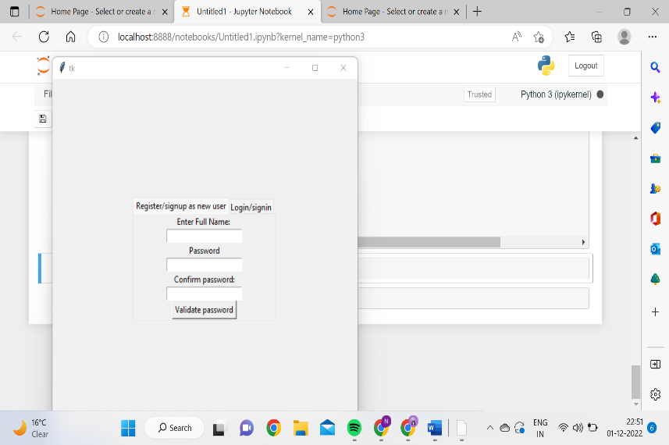

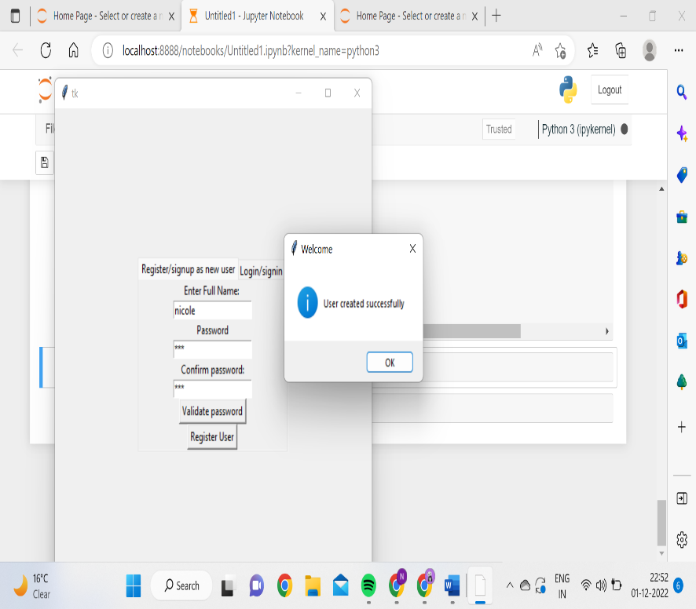

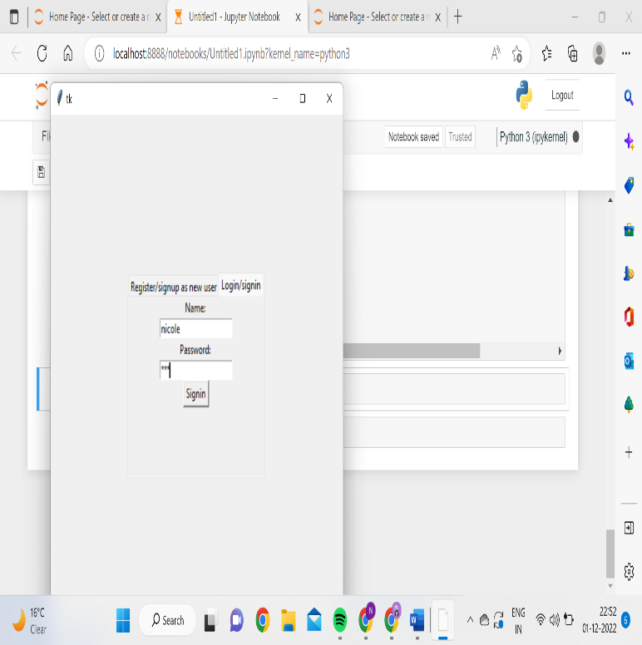

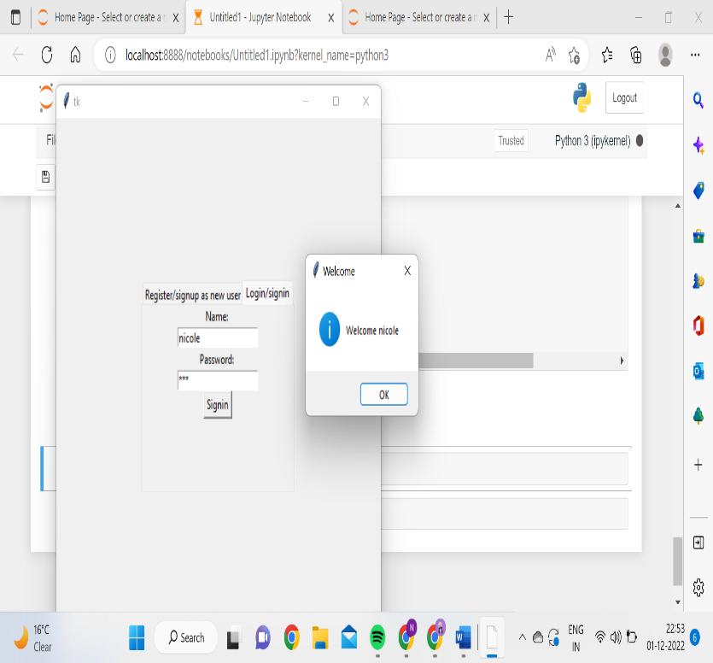

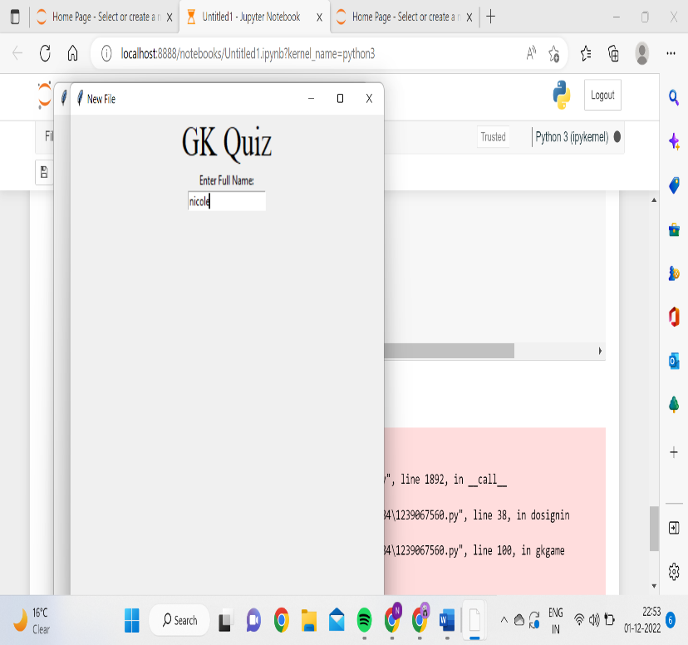

7. Conclusion:

The above project has been already implemented on a large scale by universities and other educational institutions. This is just the snippet of how the whole system works internally

Our project has limitations and which can’t be implemented only on Python

1.  For large data, implementation of SQL Databases must be done.

2.  More attention and Features should be added in Security and Privacy.

8. References